Task 1: AI-Assisted Syntax and Code Quality Review
Scenario
You join a development team and are asked to review a junior
developer’s Python script that fails to run correctly due to basic coding
mistakes. Before deployment, the code must be corrected and
standardized.
Task Description
You are given a Python script containing:
• Syntax errors
• Indentation issues
• Incorrect variable names
• Faulty function calls

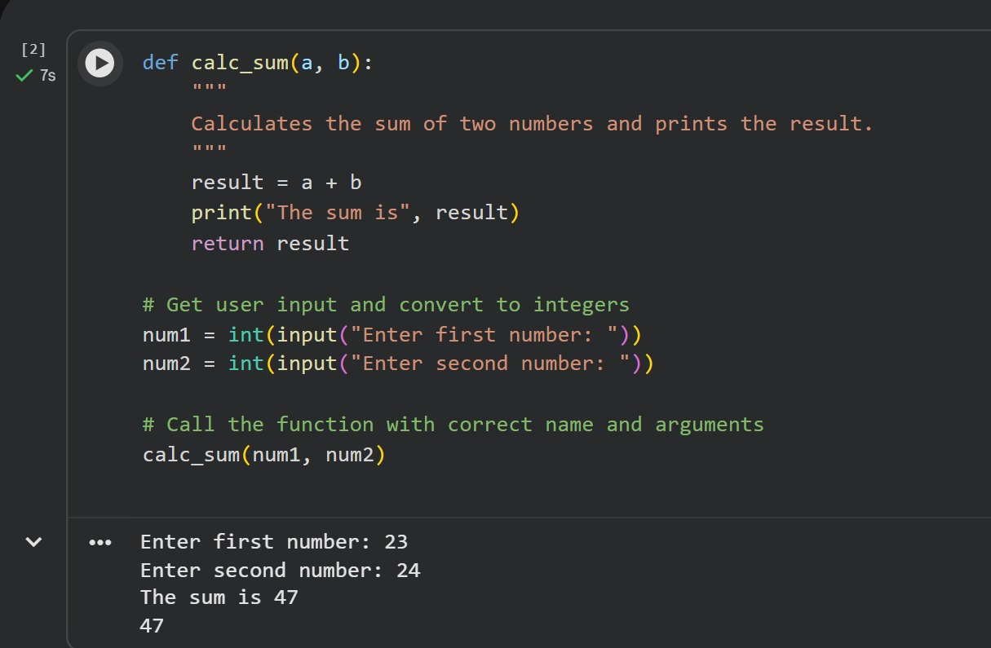

Task 2: Performance-Oriented Code Review
Scenario
A data processing function works correctly but is inefficient and slows
down the system when large datasets are used.
Task Description
You are provided with a function that identifies duplicate values in a list
using inefficient nested loops.
Using AI-assisted code review:
• Analyze the logic for performance bottlenecks
• Refactor the code for better time complexity
• Preserve the correctness of the output
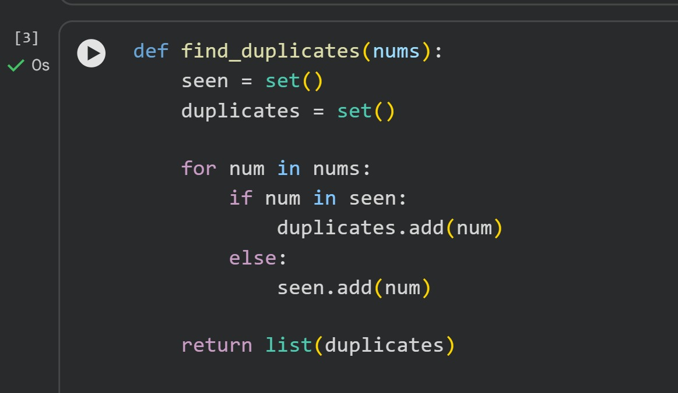

Task 3: Readability and Maintainability Refactoring
Scenario
A working script exists in a project, but it is difficult to understand due to
poor naming, formatting, and structure. The team wants it rewritten for
long-term maintainability.
Task Description
You are given a poorly structured Python function with:
• Cryptic function names
• Poor indentation
• Unclear variable naming
• No documentation

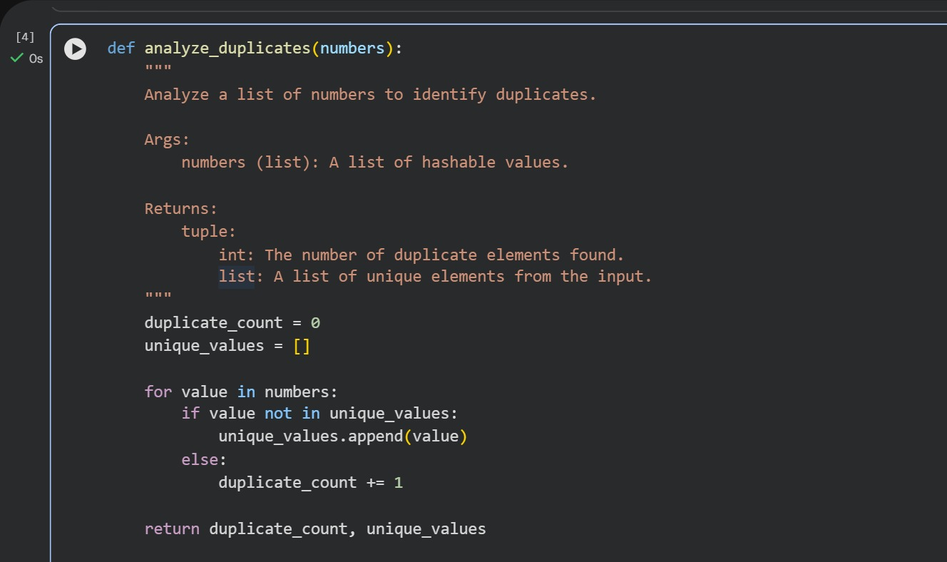
Task 4: Secure Coding and Reliability Review
Scenario
A backend function retrieves user data from a database but has security
vulnerabilities and poor error handling, making it unsafe for production
deployment.
Task Description
You are given a Python script that:
• Uses unsafe SQL query construction
• Has no input validation
• Lacks exception handling

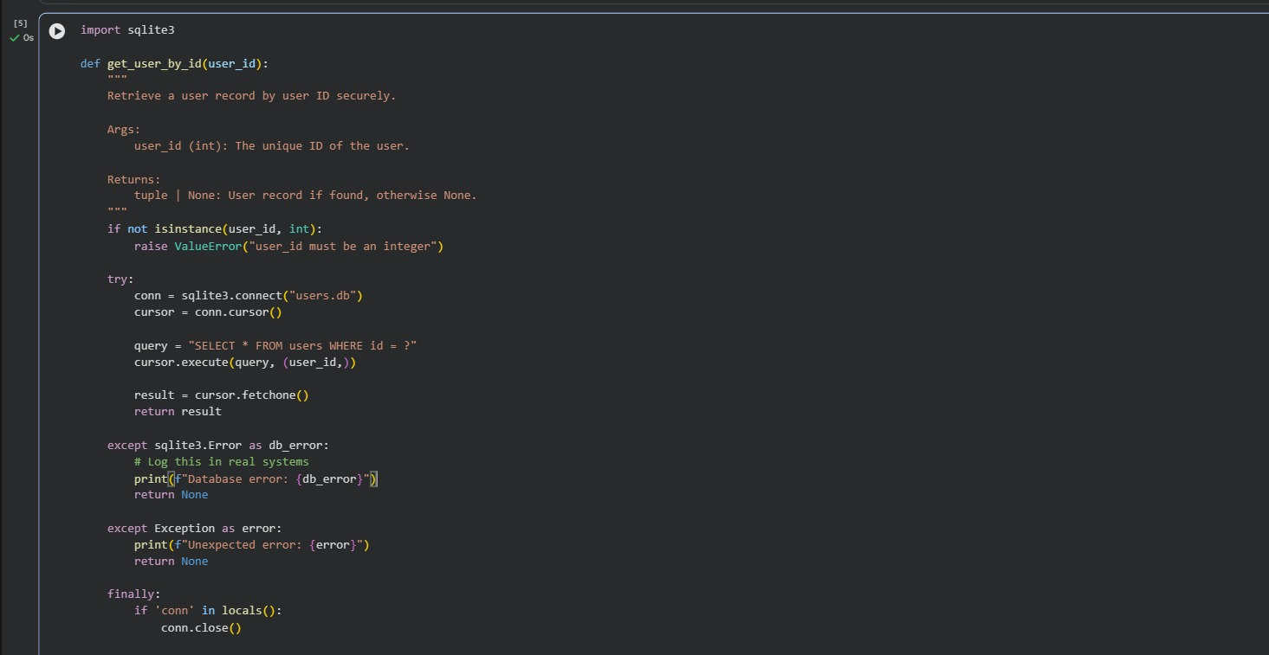
Task 5: AI-Based Automated Code Review Report
Scenario
Your team uses AI tools to perform automated preliminary code reviews
before human review, to improve code quality and consistency across
projects.
Task Description
You are provided with a poorly written Python script.
Using AI-assisted review:
• Generate a structured code review report that evaluates:
o Code readability
o Naming conventions
o Formatting and style consistency
o Error handling
o Documentation quality
o Maintainability
The task is not just to fix the code, but to analyze and report on quality
issues.
